Scorecard Requirements Specification

Scope

Overview
A scorecard is a template to produce reviews. The scorecard hierarchy consists of groups, sections and questions. Weight can be assigned on each level to control the contribution to the overall score of the scorecard. Different question types are supported and each question will allow a document, test log for instance, to be uploaded in addition. A scorecard has minimum and maximum passing score, as well as type, status and category attributes. The component defines the scorecard data structure. Separate component will be developed to provide management functionality.

Logic Requirements

Scorecard Type
A scorecard will be associated with a type. A scorecard type consists of
ID a numeric identifier
Name name of the scorecard type for display purpose

Scorecard Status
A scorecard will be associated with a status. A scorecard status consists of
ID a numeric identifier
Name name of the scorecard status for display purpose

Scorecard

Scorecard
A scorecard consists of
ID a numeric identifier
Name name of the scorecard
Version version of the scorecard, will be a String
Type each scorecard will have a type
Status each scorecard will have a status
Category scorecard will be associated with a project category, this could be
represented by a numeric identifier
Minimum Score the minimum acceptable score for the scorecard
Maximum Score the maximum acceptable score for the scorecard
Currently In Use a Boolean flag indicating whether the scorecard is currently in use
Groups one or more ordered scorecard groups as specified in 1.2.3.2

Scorecard Group
A scorecard group consists of
ID a numeric identifier
Name name of the group
Weight weight of the group in the scorecard, weights of groups in a single
scorecard should add up to 100
Sections one or more ordered scorecard sections as specified in 1.2.3.3

Scorecard Section
A scorecard section consists of
ID a numeric identifier
Name name of the section
Weight weight of the section in the group, weights of sections in a single
group should add up to 100
Questions one or more ordered scorecard questions as specified in 1.2.3.4

Scorecard Question
A scorecard question consists of
ID a numeric identifier
Type each question will have a type as specified in 1.2.4
Description the textual description for the question
Guideline the optional scoring guideline for the question
Weight weight of the question in the section, weights of questions in a single
section should add up to 100
Document Upload a Boolean flag indicating whether the question allows an attachment
Upload Required a Boolean flag indicating whether the attachment is required

Scorecard Question Type
A scorecard question will be associated with a type. A question type consists of
ID a numeric identifier
Name name of the scorecard type for display purpose
The logic to evaluate the answer based on the question type is not in the scope of this component.

Auditing Fields
Scorecard must also include auditing fields of creation/modification operator and timestamp.

Required Algorithms
No specific algorithms are required.

Example of the Software Usage
A scorecard/review application can use the component to represent scorecard in memory. Application user can create and modify scorecards on the web interface.

Future Component Direction
Separate component will be developed to calculate review scores.

Interface Requirements

Graphical User Interface Requirements
None.

External Interfaces
Design must adhere to the interface diagram definition. Designer can choose to add more methods to the classes/interfaces, but must keep the ones defined on the diagram as a minimum. Source files can be found in the distribution.
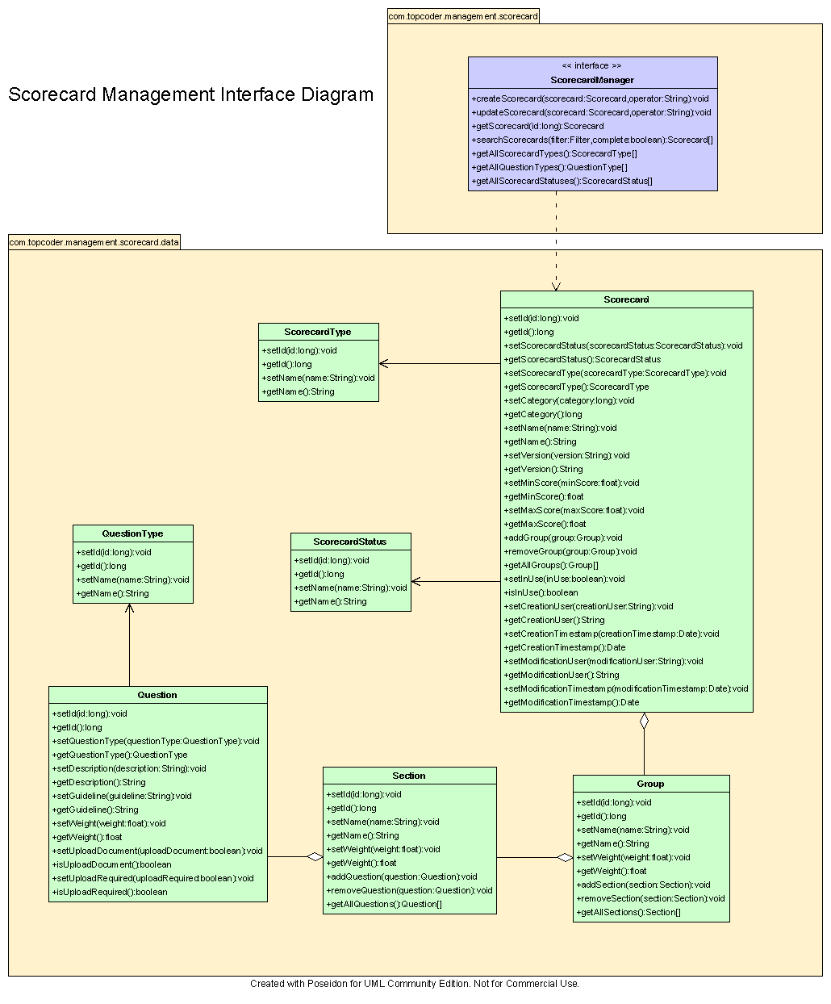

Environment Requirements
- Development language: Java1.4
- Compile target: Java1.4

Package Structure
com.topcoder.management.scorecard.data

Software Requirements

Administration Requirements

What elements of the application need to be configurable?
None.

Technical Constraints

Are there particular frameworks or standards that are required?
None.

TopCoder Software Component Dependencies:
None.

**Please review the TopCoder Software component catalog for existing components that can be used in the design.

Third Party Component, Library, or Product Dependencies:
None.

QA Environment:
- Solaris 7
- RedHat Linux 7.1
- Windows 2000
- Windows 2003

Design Constraints
The component design and development solutions must adhere to the guidelines as outlined in the TopCoder Software Component Guidelines.

Required Documentation

Design Documentation
- Use-Case Diagram
- Class Diagram
- Sequence Diagram
- Component Specification

Help / User Documentation
- Design documents must clearly define intended component usage in the ‘Documentation’ tab of Poseidon.

